LWES Spirit Wear Shop!  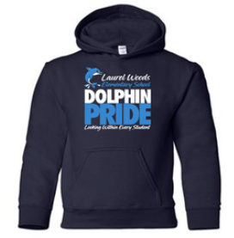  Visit:  https://lwesfall2021.itemorder.com/sale  to purchase your LWES Dolphin gear and show off your school pride!  (Shop closes September 20) | LWES Spirit Wear Shop!  Visit:  https://lwesfall2021.itemorder.com/sale  to purchase your LWES Dolphin gear and show off your school pride!  (Shop closes September 20)

